**Darlost’s Island Mouse**

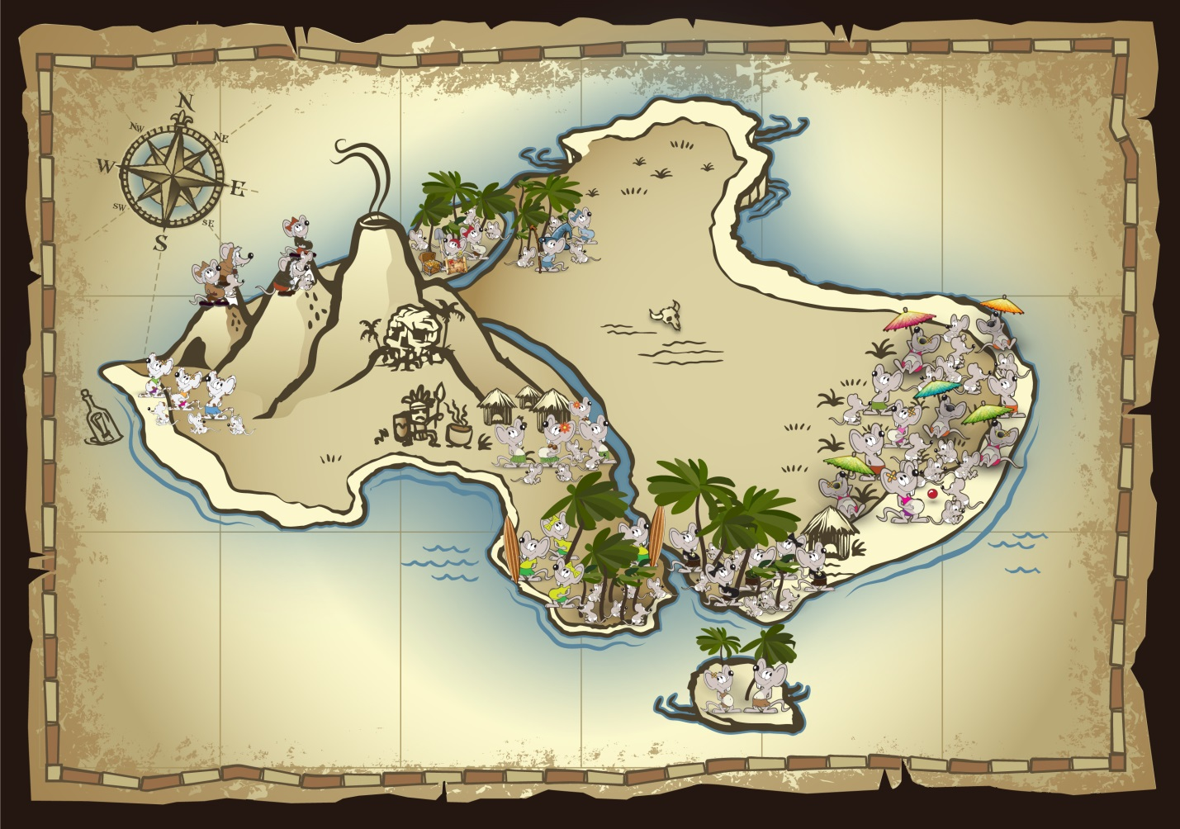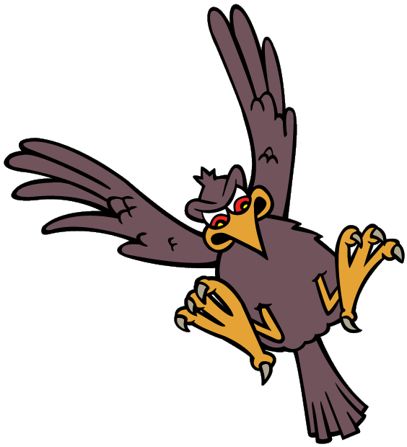

**Species Status Assessment**

**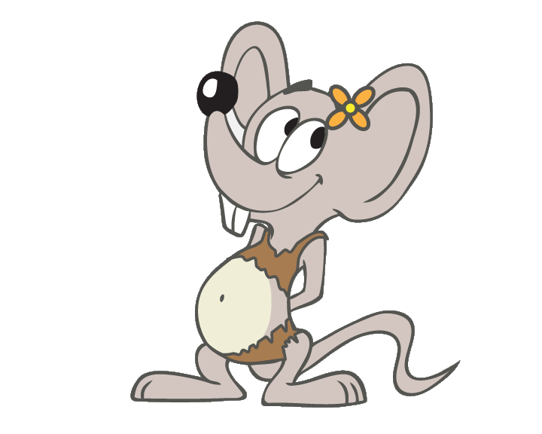****Exercise Workbook

**EXERCISE 1. LIFE CYCLE**

Diagram the life cycle of the Island Mouse and include information regarding timing, migration, or other circumstances necessary for completing the cycle.

Conceptual diagram and text

Fill in the Life cycle Table, similar to the example provided in the PowerPoint presentation.

|  |  |  |  |  |  |  |  |  |  |  |  |  |
| --- | --- | --- | --- | --- | --- | --- | --- | --- | --- | --- | --- | --- |
| **Life stage** | **Jan** | **Feb** | **Mar** | **Apr** | **May** | **Jun** | **Jul** | **Aug** | **Sep** | **Oct** | **Nov** | **Dec** |
|  |  |  |  |  |  |  |  |  |  |  |  |  |
|  |  |  |  |  |  |  |  |  |  |  |  |  |
|  |  |  |  |  |  |  |  |  |  |  |  |  |
|  |  |  |  |  |  |  |  |  |  |  |  |  |
|  |  |  |  |  |  |  |  |  |  |  |  |  |
|  |  |  |  |  |  |  |  |  |  |  |  |  |

Additional text if needed for clarification:

\_\_\_\_\_\_\_\_\_\_\_\_\_\_\_\_\_\_\_\_\_\_\_\_\_\_\_\_\_\_\_\_\_\_\_\_\_\_\_\_\_\_\_\_\_\_\_\_\_\_\_\_\_\_\_\_\_\_\_\_\_\_\_\_\_\_\_\_\_\_\_\_\_\_\_\_\_\_\_\_\_\_\_\_\_\_\_\_\_\_\_\_\_\_\_\_\_\_\_\_\_\_\_\_\_\_\_\_\_\_\_\_\_\_\_\_\_\_\_\_\_\_\_\_\_\_\_\_\_\_\_\_\_\_\_\_\_\_\_\_\_\_\_\_\_\_\_\_\_\_\_\_\_\_\_\_\_\_\_\_\_\_\_\_\_\_\_\_\_\_\_\_\_\_\_\_\_\_\_\_\_\_\_\_\_\_\_\_\_\_\_\_\_\_\_\_\_\_\_\_\_\_\_\_\_\_\_\_

**EXERCISE 2.** **RESOURCE NEEDS BY LIFE STAGE**

Using the Life Stages that were identified in Exercise 1, list the resources needed or circumstances necessary for individuals to complete each stage. Include the *FUNCTION* of each resource or circumstance (Breeding – B; Feeding – F; Sheltering – S; Migration – M; and/or Dispersal – D). After completing your list, circle SIX resources that you believe are *most important* to the species.

Key for information Source:

A – Published literature

B – Expert Elicitation

C – Writings on the Wall

D - Anecdotal

F - Tourists

|  |  |  |  |
| --- | --- | --- | --- |
| **Life Stage** | **Resources and/or circumstances needed for INDIVIDUALS to complete each life stage** | **Resource Function**  **(BFSMD?)** | **Information Source**  **A, B, C, D, F** |
|  |  |  |  |
|  |  |  |  |
|  |  |  |  |
|  |  |  |  |
|  |  |  |  |
|  |  |  |  |
|  |  |  |  |
|  |  |  |  |
|  |  |  |  |
|  |  |  |  |
|  |  |  |  |
|  |  |  |  |
|  |  |  |  |
|  |  |  |  |
|  |  |  |  |

**EXERCISE 3.** **POPULATION NEEDS**

Remember we are now starting to scale things up from Individuals to the Populations. Think about what each population NEEDS for RESILIENCY (not what it ***HAS***…that will come tomorrow). A good place to begin is to consider the evolutionary history of the species and the processes that shaped the ecosystem and the species.



**Resiliency** describes the ability of the populations to withstand stochastic events. Measured by the size and growth rate of each population, resiliency gauges the probability that the populations comprising a species are able to withstand or bounce back from environmental or demographic stochastic events; combined with representation and redundancy to form the three-pronged biodiversity principles.

Report on what you know about YOUR POPULATION ONLY. Use the interactive map to obtain more details about the populations.

1) In which ecological setting is your population? (circle one) Coastal - Paradise Palms - Mountain

2) What is your population structure? (circle one)

Metapopulation

Source

Sink

Isolated

Something else? Describe \_\_\_\_\_\_\_\_\_\_\_\_\_\_\_\_\_\_\_\_\_\_\_\_\_\_\_\_\_\_\_\_\_\_\_\_\_\_\_\_\_\_\_\_\_\_\_\_\_\_\_\_\_\_\_\_\_\_\_\_\_\_\_\_\_\_\_\_\_\_\_\_\_\_\_\_\_\_\_\_\_\_\_\_\_\_\_\_\_\_\_\_\_\_\_\_\_\_\_\_\_\_\_\_\_\_\_\_\_\_\_\_\_\_\_\_\_\_\_\_\_\_\_\_\_\_\_\_\_\_\_\_\_\_

3) Create a basic conceptual model (or influence diagram) that visually displays what resources and circumstances most influence the resiliency of your population. Start by inserting the six most important resource needs from Exercise 2 in the green boxes (habitat metrics). You may want to include the functions of those resource needs in the second column. Then, to fill in the red boxes, consider what demographic characteristics most influence population resiliency. Finally, place arrows to show how the habitat metrics (and their resource functions) influence those demographic characteristics, and then how the demographic characteristics influence population resiliency.

**Habitat Metric** **Resource Function Demographic/Distribution**  **Population Resiliency**

(Resource Need from EX 2) (Breeding, Feeding, Sheltering) (that influences population resiliency)

**Dune beetles**

**Abundance (# of individuals)**

**Feeding**

OR, design your own model based upon the basic Core Diagram here.

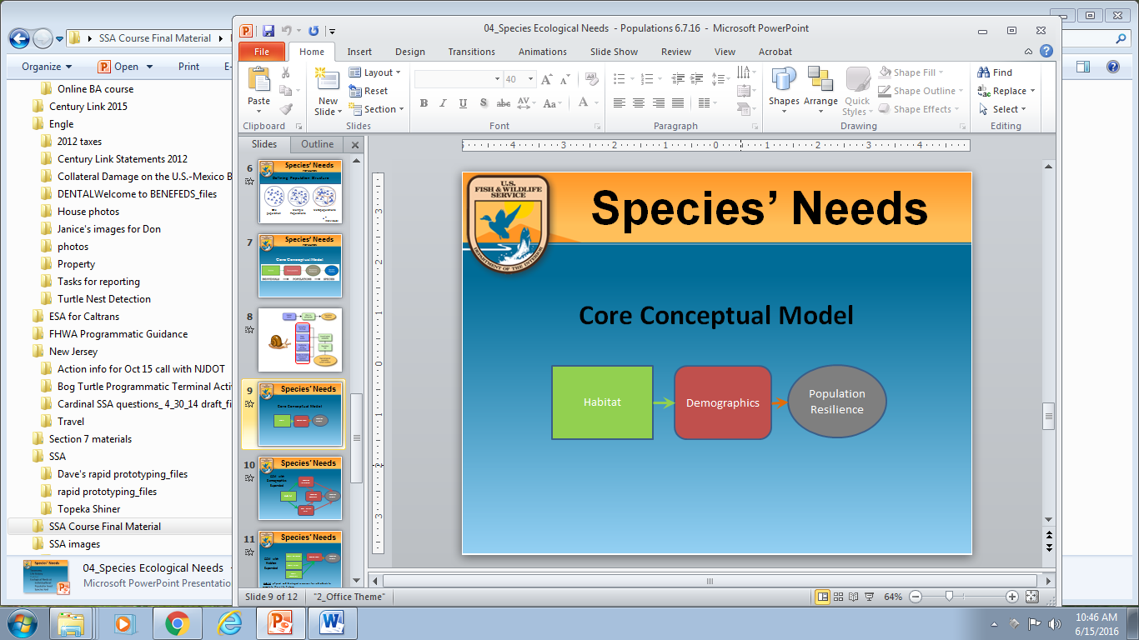

4) Resiliency is positively related to population size and growth rate and may be influenced by connectivity among populations. To help us better understand what influences resiliency for your population and how, answer these questions:

How does population size influence resiliency? Consider if this relationship is a linear or non-linear relationship. \_\_\_\_\_\_\_\_\_\_\_\_\_\_\_\_\_\_\_\_\_\_\_\_\_\_\_\_\_\_\_\_\_\_\_\_\_\_\_\_\_\_\_\_\_\_\_\_\_\_\_\_\_\_\_\_\_\_\_\_\_\_\_\_\_\_\_\_\_\_\_\_\_\_\_\_\_\_\_\_\_\_\_\_\_\_\_\_\_\_\_\_\_\_\_\_\_\_\_\_\_\_\_\_\_\_\_\_\_\_\_\_\_\_\_\_\_\_\_\_\_\_\_\_\_\_\_\_\_\_\_\_\_\_\_\_\_\_\_\_\_\_\_\_\_\_\_\_\_\_\_\_\_\_\_\_\_\_\_\_\_\_\_\_\_\_\_\_\_\_\_\_\_\_\_\_\_\_\_\_\_\_\_\_\_\_\_\_\_\_\_\_\_\_\_\_\_\_\_\_\_\_\_\_\_\_\_\_\_\_\_\_\_\_\_\_\_\_\_\_\_\_\_\_\_\_\_\_\_\_\_\_\_\_\_\_\_\_\_\_\_\_\_\_\_\_\_\_\_\_\_\_\_\_\_\_\_\_\_\_\_\_\_\_\_\_\_\_

Is there information on a minimum viable population size below which small population dynamics produce negative effects? \_\_\_\_\_\_\_\_\_\_\_\_\_\_\_\_\_\_\_\_\_\_\_\_\_\_\_\_\_\_\_\_\_\_\_\_\_\_\_\_\_\_\_\_\_\_\_\_\_\_\_\_\_\_\_\_\_\_\_\_\_\_\_\_\_\_\_\_\_\_\_\_\_\_\_\_\_\_\_\_\_\_\_\_\_\_\_\_\_\_\_\_\_\_\_\_\_\_\_\_\_\_\_\_\_\_\_\_\_\_\_\_\_\_\_\_\_\_\_\_\_\_\_\_\_\_\_\_\_\_\_\_\_\_\_\_\_\_\_\_\_\_\_\_\_\_\_\_\_\_\_\_\_\_\_\_\_\_\_\_\_\_\_\_\_\_\_\_\_\_\_\_\_\_\_\_\_\_\_\_\_\_\_\_\_\_\_\_\_\_\_\_\_\_\_\_\_\_\_\_\_\_\_\_\_\_\_\_\_\_\_\_\_\_\_\_\_\_\_\_\_\_\_\_\_\_\_\_\_\_\_\_\_\_\_\_\_\_\_\_\_\_\_\_\_\_\_\_\_\_\_\_\_\_\_\_\_\_\_\_\_\_\_\_\_\_\_\_\_\_\_\_\_\_\_\_\_\_\_\_\_\_\_\_\_\_

How do various levels of connectivity influence resiliency? (Is there a linear relationship, a minimum, a maximum?) \_\_\_\_\_\_\_\_\_\_\_\_\_\_\_\_\_\_\_\_\_\_\_\_\_\_\_\_\_\_\_\_\_\_\_\_\_\_\_\_\_\_\_\_\_\_\_\_\_\_\_\_\_\_\_\_\_\_\_\_\_\_\_\_\_\_\_\_\_\_\_\_\_\_\_\_\_\_\_\_\_\_\_\_\_\_\_\_\_\_\_\_\_\_\_\_\_\_\_\_\_\_\_\_\_\_\_\_\_\_\_\_\_\_\_\_\_\_\_\_\_\_\_\_\_\_\_\_\_\_\_\_\_\_\_\_\_\_\_\_\_\_\_\_\_\_\_\_\_\_\_\_\_\_\_\_\_\_\_\_\_\_\_\_\_\_\_\_\_\_\_\_\_\_\_\_\_\_\_\_\_\_\_\_\_\_\_\_\_\_\_\_\_\_\_\_\_\_\_\_\_\_\_\_\_\_\_\_\_\_\_\_\_\_\_\_\_\_\_\_\_\_\_\_\_\_\_\_\_\_\_\_\_\_\_\_\_\_\_\_\_\_\_\_\_\_\_\_\_\_\_\_\_\_\_\_\_\_\_\_\_\_\_\_\_\_\_\_\_\_\_\_\_\_\_\_\_\_\_\_\_\_\_\_\_\_

Using your population information as well as information from other populations (on the interactive map), fill out this Table. Transcribe your information onto the card provided and post on the large wall map next to your population’s location. Choose a member of your group to report out to the class.

Table (by population) circumstances, and resources that are NEEDED (NOT current condition).

|  |  |  |  |
| --- | --- | --- | --- |
| Population Name: | | | |
| Population Structure: (circle one) METAPOPULATION SOURCE SINK ISOLATED \_\_\_\_\_\_\_\_\_\_\_\_\_\_\_  other | | | |
| **Habitat Quality/Quantity**  (what is needed for breeding, feeding, sheltering?) | | **Abundance and Demographics**  (For example,   * # individuals * Gender ratio * Age distribution * Other\_\_\_\_\_\_\_\_\_\_\_\_\_\_\_\_\_\_) | **Distribution**  (For example,   * Distance * Connectivity * Area occupied * Other­­­­­­­­­­­­­­­­­­­­­­­­­\_\_\_\_\_\_\_\_\_\_\_\_\_\_\_\_\_) |
|  | |  |  |
| Uncertainties |  | | |

**EXERCISE 4:** **SPECIES NEEDS**

What influences representation and redundancy? (All groups together) Complete the map of the species’ range. Include all populations by placing a number for each on the map.

**COASTAL**

1. Beach Bums

2. Message in a Bottle

3. Cannibal Cove

4. Castaways

**PARADISE PALMS**

5. Snowmelt Thicket

6. Deadman’s Dunes

7. Treasure Grove

8. Realm of Spirits

**MOUNTAIN**

9. Misty Mountain

10. Darlost’s Dome

11. Skull Mountain (extirpated)

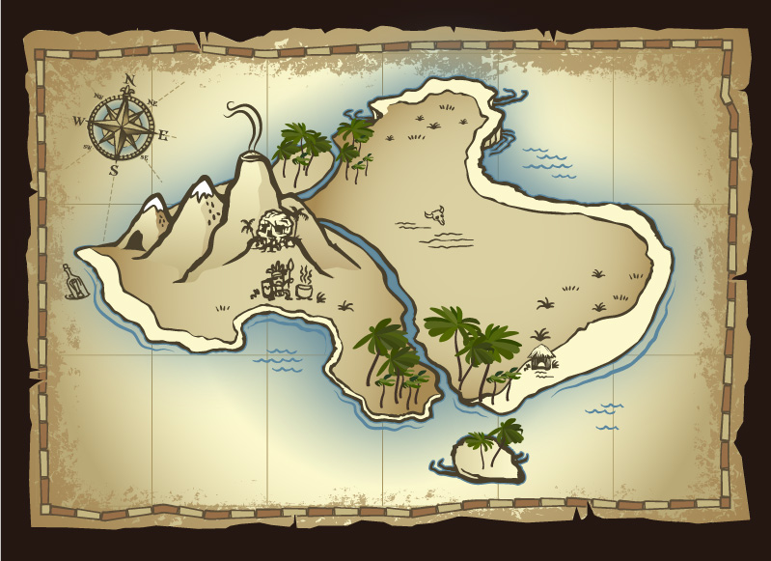

**REPRESENTATION:** Describe important geographic, genetic, and life history variation, for understanding the species ability to adapt to changing environmental conditions. Record information here.

|  |  |  |  |  |
| --- | --- | --- | --- | --- |
| Representative Variation | Habitat Type | Variation | | |
| Behavioral | Morphological | Genetic |
| Coastal |  |  |  |  |
| Paradise Palms |  |  |  |  |
| Mountains |  |  |  |  |

For the Island Mouse, the three ecological settings are fairly clear. What if there was NOT a clear distinction? How would you define representation then? \_\_\_\_\_\_\_\_\_\_\_\_\_\_\_\_\_\_\_\_\_\_\_\_\_\_\_\_\_\_\_\_\_\_\_\_\_\_\_\_\_\_\_\_\_\_\_\_\_\_\_\_\_\_\_\_\_\_\_\_\_\_\_\_\_\_\_\_\_\_\_\_\_\_\_\_\_\_\_\_\_\_\_\_\_\_\_\_\_\_\_\_\_\_\_\_\_\_\_\_\_\_\_\_\_\_\_\_\_\_\_\_\_\_\_\_\_\_\_\_\_\_\_\_\_\_\_\_\_\_\_\_\_\_\_\_\_\_\_\_\_\_\_\_\_\_\_\_\_\_\_\_\_\_\_\_\_\_\_\_\_\_\_\_\_\_\_\_\_\_\_\_\_\_

**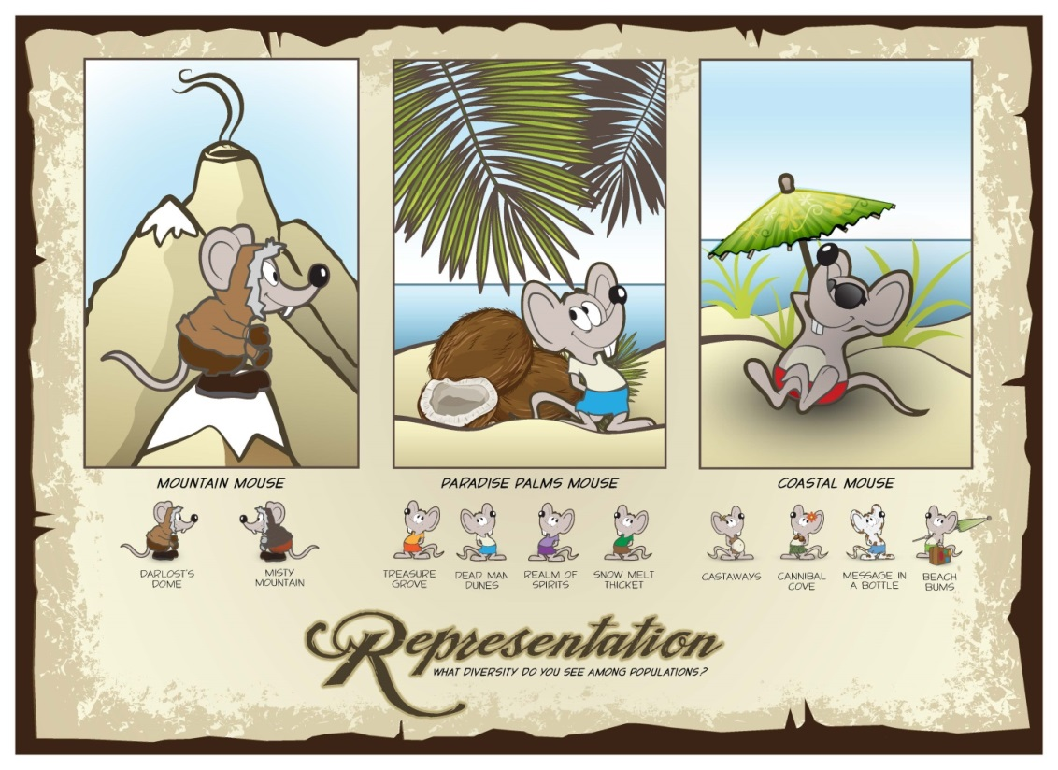**

**Representation** describes the ability of a species to adapt to changing environmental conditions. Measured by the breadth of genetic or environmental diversity within and among populations, representation gauges the probability that a species is capable of adapting to environmental changes; combined with resiliency and redundancy to form the three-pronged biodiversity principles.

**REDUNDANCY:** Multiple, resilient populations distributed within the species’ ecological settings and across the species’ range will result in redundancy.

What would be a catastrophic event for this species? \_\_\_\_\_\_\_\_\_\_\_\_\_\_\_\_\_\_\_\_\_\_\_\_\_\_\_\_\_\_\_\_\_\_\_\_\_\_\_\_\_\_\_\_\_\_\_\_\_\_\_\_\_\_\_\_\_\_\_\_\_\_\_\_\_\_\_\_\_\_\_\_\_\_\_\_\_\_\_\_\_\_\_\_\_

What is the ability of this species to withstand catastrophic events? \_\_\_\_\_\_\_\_\_\_\_\_\_\_\_\_\_\_\_\_\_\_\_\_\_\_\_\_\_\_\_\_\_\_\_\_\_\_\_\_\_\_\_\_\_\_\_\_\_\_\_\_\_\_\_\_\_\_\_\_\_\_\_\_\_\_\_\_\_\_\_\_\_\_\_\_\_\_\_\_\_\_\_\_\_\_\_\_\_\_\_\_\_\_\_\_\_\_\_\_\_\_\_\_\_\_\_\_\_\_\_\_\_\_\_\_\_\_\_\_\_\_\_\_\_\_\_\_\_\_\_\_\_\_\_\_\_\_\_\_\_\_\_\_\_\_\_\_\_\_\_\_\_\_\_\_\_\_\_\_\_\_\_\_\_\_\_\_\_\_\_\_\_\_

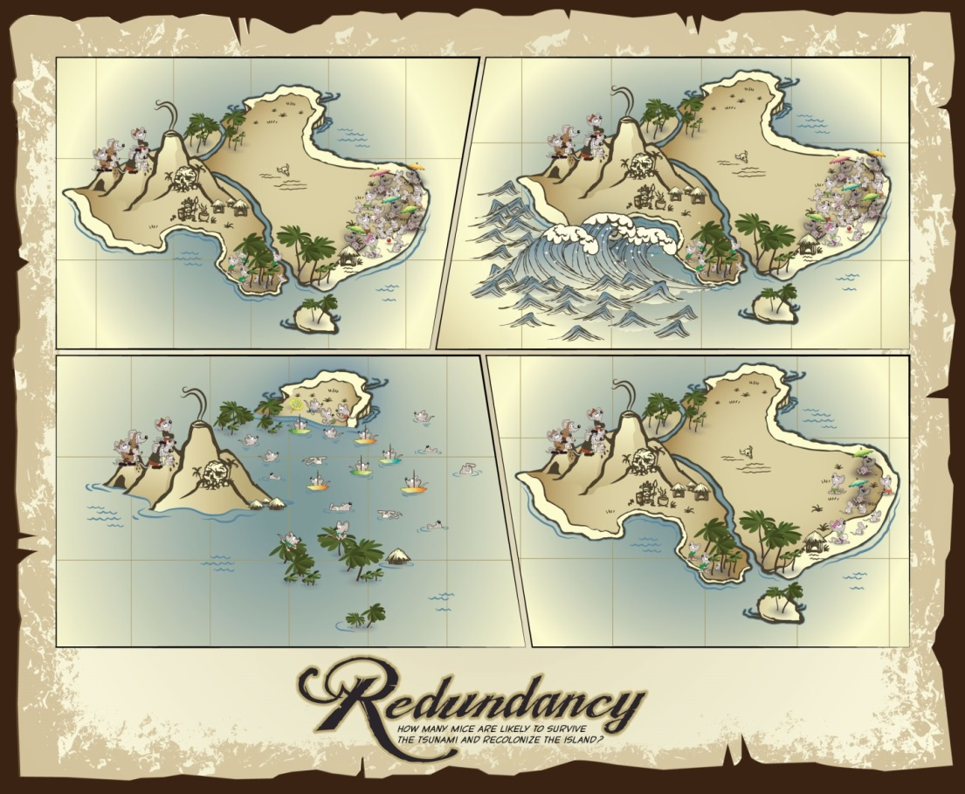How do populations need to be dispersed to reduce the risk of extirpation from catastrophic events? \_\_\_\_\_\_\_\_\_\_\_\_\_\_\_\_\_\_\_\_\_\_\_\_\_\_\_\_\_\_\_\_\_\_\_\_\_\_\_\_\_\_\_\_\_\_\_\_\_\_\_\_\_\_\_\_\_\_\_\_\_\_\_\_\_\_\_\_\_\_\_\_\_\_\_\_\_\_\_\_\_\_\_\_\_\_\_\_\_\_\_\_\_\_\_\_\_\_\_\_\_\_\_\_\_\_\_\_\_\_\_\_\_\_\_\_\_\_\_\_\_\_\_\_\_\_\_\_\_\_\_\_\_\_\_\_\_\_\_\_\_\_\_\_\_\_\_\_\_\_\_\_\_\_\_\_\_\_\_\_\_\_\_\_\_\_\_\_\_\_\_\_\_\_

**Redundancy** describes the ability of a species to withstand catastrophic events. Measured by the number of populations, their resiliency, and their distribution (and connectivity), redundancy gauges the probability that the species has a margin of safety to withstand or can bounce back from catastrophic events; combined with resiliency and representation to form the three-pronged biodiversity principles.

What are some uncertainties at this point? \_\_\_\_\_\_\_\_\_\_\_\_\_\_\_\_\_\_\_\_\_\_\_\_\_\_\_\_\_\_\_\_\_\_\_\_\_\_\_\_\_\_\_\_\_\_\_\_\_\_\_\_\_\_\_\_\_\_\_\_\_\_\_\_\_\_\_\_\_\_\_\_\_\_\_\_\_\_\_\_\_\_\_\_\_\_\_\_\_\_\_\_\_\_\_\_\_\_\_\_\_\_\_\_\_\_\_\_\_\_\_\_\_\_\_\_\_\_\_\_\_\_\_\_\_\_\_\_\_\_\_\_\_\_\_\_\_\_\_\_\_\_\_\_\_\_\_\_\_\_\_\_\_\_\_\_\_\_\_\_\_\_\_\_\_\_\_\_\_\_\_\_\_\_

**EXERCISE 5.** **CURRENT CONDITION**

Report on what you know about YOUR POPULATION ONLY. Using the data for your population found in the interactive map, create a graph of the trend. If you know a range that represents population numbers NEEDED (from Tuesday, Exercise 3), color in that range here. For example, if you know the population needs 250-600 individuals, shade in those rows.

Considering the information you placed on this chart for what your population NEEDS (in Exercise 3), use your trend data to describe what the population HAS today (the CURRENT CONDITION).

|  |  |  |  |
| --- | --- | --- | --- |
| Population Name: | | | |
| Population Structure: (circle one) METAPOPULATION SOURCE SINK ISOLATED \_\_\_\_\_\_\_\_\_\_\_\_\_\_\_  other | | | |
| **Habitat Quality/Quantity**  (what is needed for breeding, feeding, sheltering?) | | **Abundance and Demographics**  (For example,   * # individuals * Gender ratio * Age distribution * Other\_\_\_\_\_\_\_\_\_\_\_\_\_\_\_\_\_\_) | **Distribution**  (For example,   * Distance * Connectivity * Area occupied * Other­­­­­­­­­­­­­­­­­­­­­­­­­\_\_\_\_\_\_\_\_\_\_\_\_\_\_\_\_\_) |
|  | |  |  |
| Uncertainties |  | | |

Transcribe the Graph and Table you just completed onto the cards provided and post on the large wall map next to your population’s location. At the end of this exercise, each population on the wall map should have three cards –needs, trend, and current condition. Select a speaker for your group to report out on the trend and current condition.

**EXERCISE 6.** **ASSESSING REASONS FOR CURRENT CONDITION: UNDERSTANDING CAUSE AND EFFECT**

Build logic chains for the terminal activities “walk through habitat” and “use heavy construction equipment”.

Develop logic chains (examples are in red), based upon what you know for your population only. Fill in the light grey boxes in the Table below, creating a direct and an indirect pathway for both. We will discuss how individual effects scale up to population and species effects when we re-group. But first, considering the videos on the effects of blasting, let’s complete the first pathway together…

|  |  |  |  |  |  |  |  |  |  |  |
| --- | --- | --- | --- | --- | --- | --- | --- | --- | --- | --- |
| ***Activity*** | ***Exposure*** | | ***Biology*** | | | ***Consequences*** | | | | |
| ***Individuals*** | | ***Populations*** | ***Species*** | ***A/M/M*** |
| ***Terminal Activity***  *(pick one or two from list above)* | ***DIRECT Interaction***  *(vehicle strike, crushing, trampling, etc.)* | ***INDIRECT interaction***  *(Stressor) What is the change?* | ***Resource or Individuals Exposed*** | ***Life stage affected*** *(of the species)* | ***Resource Functions*** *(B/F/S/M/D)* | ***Responses to exposure*** | ***Effects*** | ***Effects to Reproduction, Numbers, Distribution*** | ***RepresentationResilience Redundancy*** |  |
| blasting |  | in noise above 60db |  |  |  |  |  |  |  |  |
| vegetation removal |  | in shade | Paradise Palm trees | juveniles | sheltering | abandon site | Reduced forag-ing success> delayed maturity |  |  |  |
| drive golf carts | vehicle strike |  | Individual mice | adults |  | trauma | death |  |  |  |
| Walk through habitat |  |  |  |  |  |  |  |  |  |  |
|  |  |  |  |  |  |  |  |  |  |
| Use heavy construction equipment |  |  |  |  |  |  |  |  |  |  |
|  |  |  |  |  |  |  |  |  |  |
|  |  |  |  |  |  |  |  |  |  |  |

**EXERCISE 7.** **CURRENT CONDITION** **INFLUENCE DIAGRAMS**

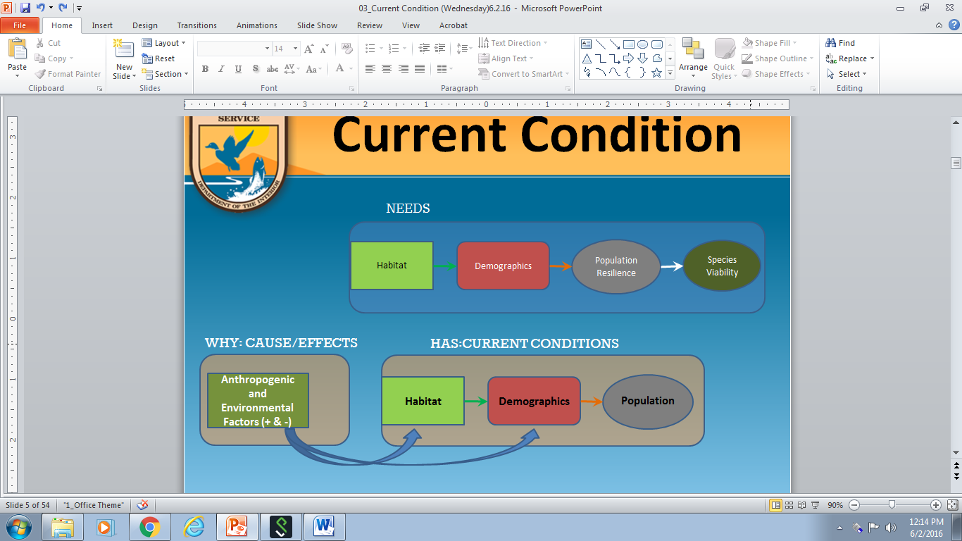A. Develop conceptual models for indicating what influences current population resiliency within your POPULATION (include both *positive and negative* influences). To start, bring over the basic core conceptual model components from Exercise 3, and then add anthropogenic and environmental factors that influence the habitat metrics or demographics. Put an \* next to which factors are MOST influential and add + or – if they are positive or negative influences. Copy onto 11x17 paper and post with the Ecological Setting (next page) conceptual model.

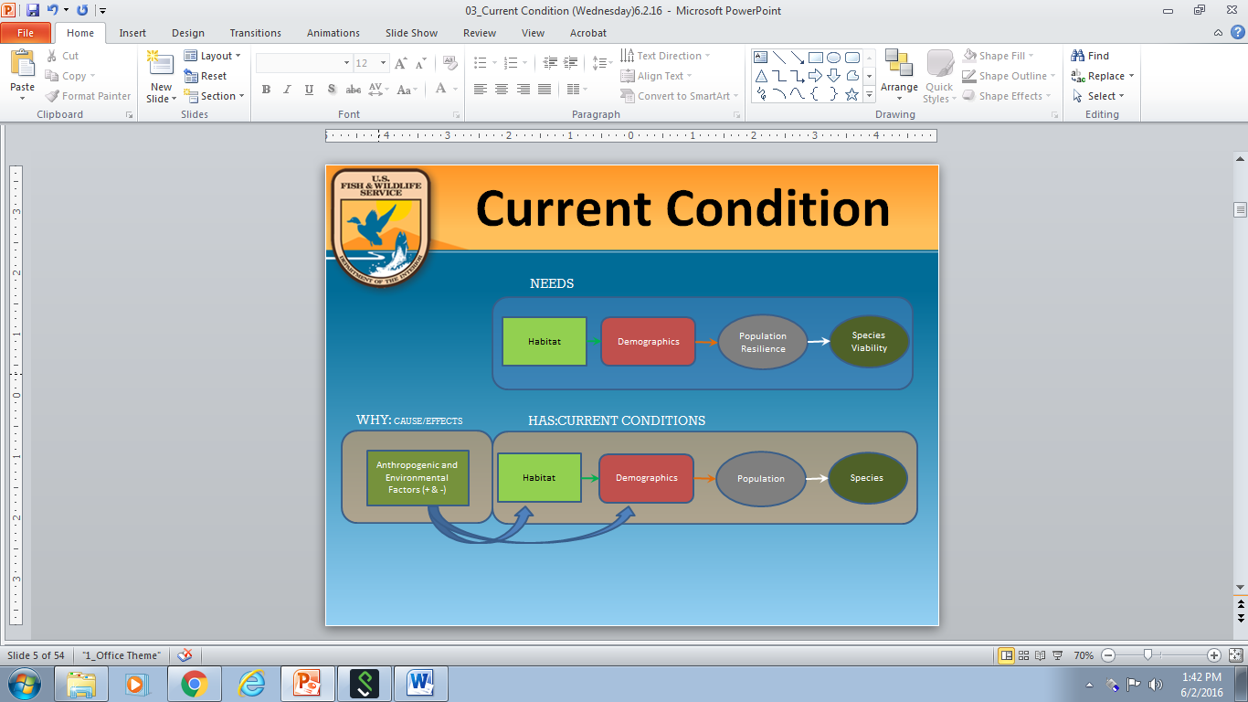B. After each population has a conceptual model, re-group with those in your ECOLOGICAL SETTING to create a conceptual model. With a coach using the Mental Modeler, start with commonalities and build influence pathways together. Copy your Ecological Setting’s final diagram here and post a copy (11x17) on the back wall.

**C. Based upon this model, what are the THREE most influential demographic factors and the THREE most influential habitat factors for this Ecological Setting?**

**Demographic Factors: Habitat Factors:**

1.\_\_\_\_\_\_\_\_\_\_\_\_\_\_\_\_\_\_\_\_\_\_\_\_\_\_\_\_\_\_\_\_\_\_\_\_\_\_\_\_\_\_\_\_\_\_ 1.\_\_\_Dune Beetle\_\_\_\_\_\_\_\_\_\_\_\_\_\_\_\_\_\_\_\_\_\_\_\_\_\_\_\_\_\_\_\_\_\_\_

2.\_\_\_\_\_\_\_\_\_\_\_\_\_\_\_\_\_\_\_\_\_\_\_\_\_\_\_\_\_\_\_\_\_\_\_\_\_\_\_\_\_\_\_\_\_\_ 2.\_\_\_\_\_\_\_\_\_\_\_\_\_\_\_\_\_\_\_\_\_\_\_\_\_\_\_\_\_\_\_\_\_\_\_\_\_\_\_\_\_\_\_\_\_\_\_\_

3.\_\_\_\_\_\_\_\_\_\_\_\_\_\_\_\_\_\_\_\_\_\_\_\_\_\_\_\_\_\_\_\_\_\_\_\_\_\_\_\_\_\_\_\_\_\_ 3.\_\_\_\_\_\_\_\_\_\_\_\_\_\_\_\_\_\_\_\_\_\_\_\_\_\_\_\_\_\_\_\_\_\_\_\_\_\_\_\_\_\_\_\_\_\_\_\_

**[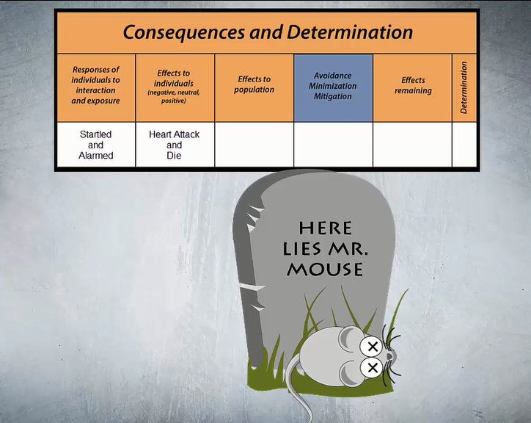](file:///C:\Users\jengle\Desktop\Videos\mouseresponse.mp4)**

**What are the six most influential stressors in your Ecological Setting?**

**1.\_\_\_\_**Noise above 60 db\_**\_\_\_\_\_\_\_\_\_\_\_\_\_\_\_\_\_\_\_\_\_\_\_­\_\_\_\_\_\_\_\_\_\_\_\_\_**

**2.\_\_\_\_\_\_\_\_\_\_\_\_\_\_\_\_\_\_\_\_\_\_\_\_\_\_\_\_\_\_\_\_\_\_\_\_\_\_\_\_\_\_\_\_\_\_\_\_\_\_\_\_\_\_\_\_**

**3.\_\_\_\_\_\_\_\_\_\_\_\_\_\_\_\_\_\_\_\_\_\_\_\_\_\_\_\_\_\_\_\_\_\_\_\_\_\_\_\_\_\_\_\_\_\_\_\_\_\_\_\_\_\_\_\_**

**4.\_\_\_\_\_\_\_\_\_\_\_\_\_\_\_\_\_\_\_\_\_\_\_\_\_\_\_\_\_\_\_\_\_\_\_\_\_\_\_\_\_\_\_\_\_\_\_\_\_\_\_\_\_\_\_\_**

**5.\_\_\_\_\_\_\_\_\_\_\_\_\_\_\_\_\_\_\_\_\_\_\_\_\_\_\_\_\_\_\_\_\_\_\_\_\_\_\_\_\_\_\_\_\_\_\_\_\_\_\_\_\_\_\_\_**

**6.\_\_\_\_\_\_\_\_\_\_\_\_\_\_\_\_\_\_\_\_\_\_\_\_\_\_\_\_\_\_\_\_\_\_\_\_\_\_\_\_\_\_\_\_\_\_\_\_\_\_\_\_\_\_\_\_**

**Exercise 8**. **POPULATION** **RESILIENCE**

In Exercise 3 you described what your population’s needs and circumstances are. Considering that and the influence diagram, develop a categorical scale to clarify what High, Moderate, and Low population resilience would be for three demographic factors and three habitat factors. One demographic and one habitat factor have been pre-selected. Choose two more of each to carry forward as a class. Use the calibrated risk language below. Let’s consider resiliency over 50 years, which matches with how we are thinking about foreseeable future. (Class does this together)

|  |  |  |  |
| --- | --- | --- | --- |
| **Overall condition based on resiliency** | **Risk** | **Persistence over 50 years** | **Probability of persistence** |
| High | Low | Very likely | 90-100% |
| Moderate | Moderate | Likely | 66-90% |
| Low | High | About as likely as not and unlikely | 0-66% |

|  |  |  |  |  |  |  |
| --- | --- | --- | --- | --- | --- | --- |
|  | **Demographic Factors** | | | **Habitat Factors** | | |
| Condition category | abundance |  |  | beetle abundance |  |  |
| **HIGH** |  |  |  |  |  |  |
| **MODERATE** |  |  |  |  |  |  |
| **LOW** |  |  |  |  |  |  |

Assess the current condition of each factor for your population (low, medium, high) and record on the Current Condition (by factor) poster.

|  |  |  |  |  |  |  |
| --- | --- | --- | --- | --- | --- | --- |
| Population Name: | | | | | | |
| **Demographic Factors** | | | **Habitat Factors** | | | (overall) |
| abundance |  |  | beetle abundance |  |  | Current Condition |
|  |  |  |  |  |  |  |

Record factor scores for each population to discuss overall current condition with class.

|  |  |  |  |  |  |  |  |
| --- | --- | --- | --- | --- | --- | --- | --- |
| **Population name** | **Demographic Factors** | | | **Habitat Factors** | | |  |
| abundance |  |  | beetle abundance |  |  | Current Condition (overall) |
| Beach Bums |  |  |  |  |  |  |  |
| Message in a Bottle |  |  |  |  |  |  |  |
| Cannibal Cove |  |  |  |  |  |  |  |
| Castaways |  |  |  |  |  |  |  |
| Snowmelt Thicket |  |  |  |  |  |  |  |
| Deadman’s Dunes |  |  |  |  |  |  |  |
| Treasure Grove |  |  |  |  |  |  |  |
| Realm of Spirits |  |  |  |  |  |  |  |
| Misty Mountain |  |  |  |  |  |  |  |
| Darlost’s Dome |  |  |  |  |  |  |  |
| Skull Mountain |  |  |  |  |  |  |  |

How certain are you of the current condition of your population?

\_\_\_\_\_\_\_\_\_\_\_\_\_\_\_\_\_\_\_\_\_\_\_\_\_\_\_\_\_\_\_\_\_\_\_\_\_\_\_\_\_\_\_\_\_\_\_\_\_\_\_\_\_\_\_\_\_\_\_\_\_\_\_\_\_\_\_\_\_\_\_\_\_\_\_\_\_\_\_\_\_\_\_\_\_\_\_\_\_\_\_\_\_\_\_\_\_\_\_\_\_\_\_\_\_\_\_\_\_\_\_\_\_\_\_\_\_\_\_\_\_\_\_\_\_\_\_\_\_\_\_\_\_\_\_\_\_\_\_\_\_\_\_\_\_\_\_\_\_\_\_\_\_\_\_\_\_\_\_\_\_\_\_\_\_\_\_\_\_\_\_\_\_\_

\_\_\_\_\_\_\_\_\_\_\_\_\_\_\_\_\_\_\_\_\_\_\_\_\_\_\_\_\_\_\_\_\_\_\_\_\_\_\_\_\_\_\_\_\_\_\_\_\_\_\_\_\_\_\_\_\_\_

Textually summarizing and describing the most important information from tables, graphs, etc. will be a skill needed when you go to write an SSA report. Practice that skill here by characterizing the abundance (Resiliency) and distribution (Redundancy) within each Ecological Setting (Representation). Write in complete sentences, as if this will be cut-and-pasted into your SSA document. Remember, this is current condition (we project in the next exercise).

**Coastal:** \_\_\_\_\_\_\_\_\_\_\_\_\_\_\_\_\_\_\_\_\_\_\_\_\_\_\_\_\_\_\_\_\_\_\_\_\_\_\_\_\_\_\_\_\_\_\_\_\_\_\_\_\_\_\_\_\_\_\_\_\_\_\_\_\_\_\_\_\_\_\_\_\_\_\_\_\_\_\_\_\_\_\_\_\_\_\_\_\_\_\_\_\_\_\_\_\_\_\_\_\_\_\_\_\_\_\_\_\_\_\_\_\_\_\_\_\_\_\_\_\_\_\_\_\_\_\_\_\_\_\_\_\_\_\_\_\_\_\_\_\_\_\_\_\_\_\_\_\_\_\_\_\_\_\_\_\_\_\_\_\_\_\_\_\_\_\_\_\_\_\_\_\_\_\_\_\_\_\_\_\_\_\_\_\_\_\_\_\_\_\_\_\_\_\_\_\_\_\_\_\_\_\_\_\_\_\_\_\_\_\_\_\_\_\_\_\_\_\_\_\_\_\_\_\_\_\_\_\_\_\_\_\_\_\_\_\_\_\_\_\_\_\_\_\_\_\_\_\_\_\_\_\_\_\_\_\_\_\_\_\_\_\_\_\_\_\_\_\_\_\_\_\_\_\_\_\_\_\_\_\_\_\_\_\_\_\_\_\_\_\_\_\_\_\_\_\_\_\_\_\_\_\_\_\_\_\_\_\_\_\_\_\_\_\_\_\_\_\_\_\_\_\_\_\_\_\_\_\_\_\_\_\_\_\_\_\_\_\_\_\_\_\_\_\_\_\_\_\_\_\_\_\_\_\_\_\_\_\_\_\_\_\_\_\_\_\_\_\_\_\_\_\_\_\_\_\_\_\_\_\_\_\_\_\_\_\_\_\_\_\_\_\_\_\_\_\_\_\_\_\_\_\_\_\_\_\_\_\_\_\_\_\_\_\_\_\_\_\_\_\_\_\_\_\_\_\_\_\_\_\_\_\_\_\_\_\_\_\_\_\_\_\_\_\_\_\_\_\_\_\_\_\_\_\_\_\_\_\_\_\_\_\_\_

**Paradise Palms:** \_\_\_\_\_\_\_\_\_\_\_\_\_\_\_\_\_\_\_\_\_\_\_\_\_\_\_\_\_\_\_\_\_\_\_\_\_\_\_\_\_\_\_\_\_\_\_\_\_\_\_\_\_\_\_\_\_\_\_\_\_\_\_\_\_\_\_\_\_\_\_\_\_\_\_\_\_\_\_\_\_\_\_\_\_\_\_\_\_\_\_\_\_\_\_\_\_\_\_\_\_\_\_\_\_\_\_\_\_\_\_\_\_\_\_\_\_\_\_\_\_\_\_\_\_\_\_\_\_\_\_\_\_\_\_\_\_\_\_\_\_\_\_\_\_\_\_\_\_\_\_\_\_\_\_\_\_\_\_\_\_\_\_\_\_\_\_\_\_\_\_\_\_\_\_\_\_\_\_\_\_\_\_\_\_\_\_\_\_\_\_\_\_\_\_\_\_\_\_\_\_\_\_\_\_\_\_\_\_\_\_\_\_\_\_\_\_\_\_\_\_\_\_\_\_\_\_\_\_\_\_\_\_\_\_\_\_\_\_\_\_\_\_\_\_\_\_\_\_\_\_\_\_\_\_\_\_\_\_\_\_\_\_\_\_\_\_\_\_\_\_\_\_\_\_\_\_\_\_\_\_\_\_\_\_\_\_\_\_\_\_\_\_\_\_\_\_\_\_\_\_\_\_\_\_\_\_\_\_\_\_\_\_\_\_\_\_\_\_\_\_\_\_\_\_\_\_\_\_\_\_\_\_\_\_\_\_\_\_\_\_\_\_\_\_\_\_\_\_\_\_\_\_\_\_\_\_\_\_\_\_\_\_\_\_\_\_\_\_\_\_\_\_\_\_\_\_\_\_\_\_\_\_\_\_\_\_\_\_\_\_\_\_\_\_\_\_\_\_\_\_\_\_\_\_\_\_\_\_\_\_\_\_\_\_\_\_\_\_\_\_\_\_\_\_\_\_\_\_\_\_\_\_\_\_\_\_\_\_\_\_\_\_\_\_\_\_\_\_\_\_\_\_\_\_\_\_\_\_\_\_\_\_\_

**Mountain:**

\_\_\_\_\_\_\_\_\_\_\_\_\_\_\_\_\_\_\_\_\_\_\_\_\_\_\_\_\_\_\_\_\_\_\_\_\_\_\_\_\_\_\_\_\_\_\_\_\_\_\_\_\_\_\_\_\_\_\_\_\_\_\_\_\_\_\_\_\_\_\_\_\_\_\_\_\_\_\_\_\_\_\_\_\_\_\_\_\_\_\_\_\_\_\_\_\_\_\_\_\_\_\_\_\_\_\_\_\_\_\_\_\_\_\_\_\_\_\_\_\_\_\_\_\_\_\_\_\_\_\_\_\_\_\_\_\_\_\_\_\_\_\_\_\_\_\_\_\_\_\_\_\_\_\_\_\_\_\_\_\_\_\_\_\_\_\_\_\_\_\_\_\_\_\_\_\_\_\_\_\_\_\_\_\_\_\_\_\_\_\_\_\_\_\_\_\_\_\_\_\_\_\_\_\_\_\_\_\_\_\_\_\_\_\_\_\_\_\_\_\_\_\_\_\_\_\_\_\_\_\_\_\_\_\_\_\_\_\_\_\_\_\_\_\_\_\_\_\_\_\_\_\_\_\_\_\_\_\_\_\_\_\_\_\_\_\_\_\_\_\_\_\_\_\_\_\_\_\_\_\_\_\_\_\_\_\_\_\_\_\_\_\_\_\_\_\_\_\_\_\_\_\_\_\_\_\_\_\_\_\_\_\_\_\_\_\_\_\_\_\_\_\_\_\_\_\_\_\_\_\_\_\_\_\_\_\_\_\_\_\_\_\_\_\_\_\_\_\_\_\_\_\_\_\_\_\_\_\_\_\_\_\_\_\_\_\_\_\_\_\_\_\_\_\_\_\_\_\_\_\_\_\_\_\_\_\_\_\_\_\_\_\_\_\_\_\_\_\_\_\_\_\_\_\_\_\_\_\_\_\_\_\_\_\_\_\_\_\_\_\_\_\_\_\_\_\_\_\_\_\_\_\_\_\_\_\_\_\_\_\_\_\_\_\_\_\_\_\_\_\_\_\_\_\_\_\_\_\_\_\_\_\_\_

**Exercise 9**. **SCENARIO DEVELOPMENT**

**Part A. Evaluating Future Stressors** (complete in Population groups)

Consider which stressors will continue into the future and if they are going to increase, decrease, or stay the same (circle appropriate arrow). Which may no longer be acting? Are there any emerging stressors? (If so, add them in the blank rows at the bottom of the Table.)

After completing the Table, refer to Exercise 7 and, together with the analysis you just completed, determine if you need to re- rank any of the stressors. (Cross through old rank and circle new one, if different.)

|  |  |  |  |  |
| --- | --- | --- | --- | --- |
|  | **Rank Stressors**  **1-6**  **(from EX 7)** | **What is the effect of climate change?**  **(decrease, increase, no change: circle one arrow)** | **Describe the Effects of the Stressors on Resources or Demographic Factors** | **Potential Conservation Actions** |
| rat-proof1 |  | up_down[1] |  |  |
| Jacks-Sparrow |  | up_down[1] |  |  |
| no-sound-vector-sign-isolated-white-34881584[1] | **1** | up_down[1] | Increase in island-wide thunderstorms with thunder bursts exceeding 60db. | Create artificial burrow refugia |
| 1372502250[1] |  | up_down[1] |  |  |
|  |  | up_down[1] |  |  |
|  |  | up_down[1] |  |  |
|  |  | up_down[1] |  |  |
| ClimateChangeTemperatures[1]ms-flood[1] |  | up_down[1] | Sea level rise will inundate beetle breeding, resulting in a reduction of beetle numbers, with the potential to increase mortality. |  |
|  |  | up_down[1] |  |  |
| MALDIVES_VECTOR2C[1] |  | up_down[1] |  |  |
| lightning_bolt__s_cutie_mark_by_creshosk-d4175li[1] |  | up_down[1] |  |  |
| disegno-vento[1] |  | up_down[1] |  |  |
|  |  |  |  |  |
|  |  |  |  |  |

**Part B. Species Scale Scenarios** (complete in class together)

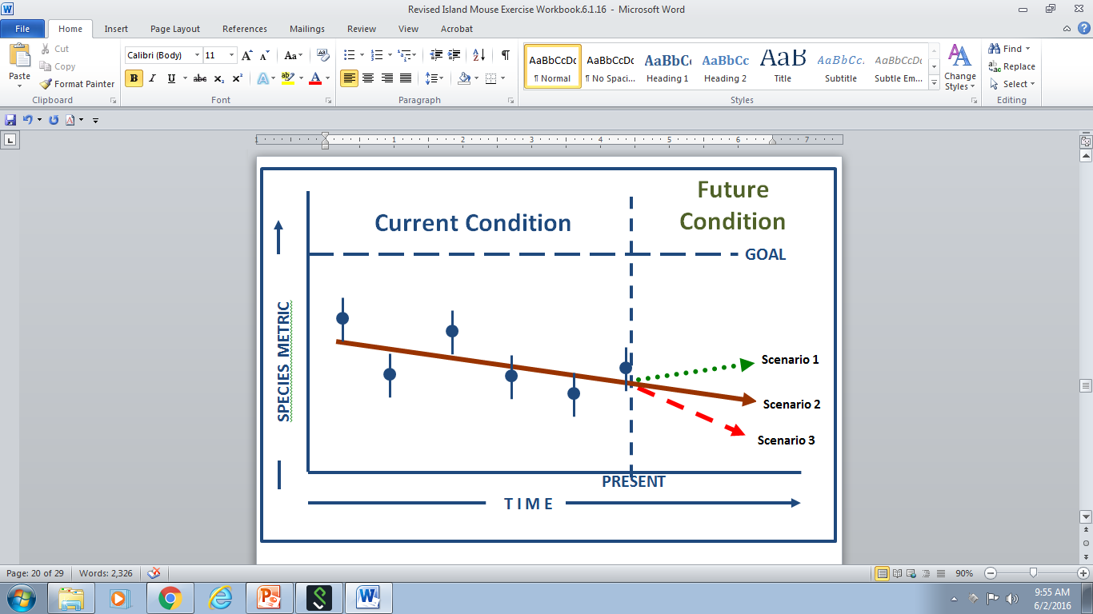**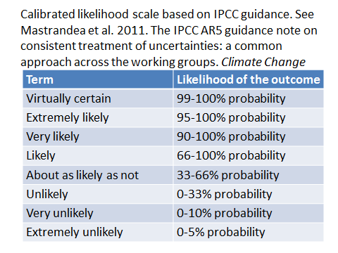**Using the Climate Fact Sheet, the Threats Fact Sheet and your Population Fact Sheet, (and the interactive map) develop three future scenarios: optimistic (stressors decrease), moderate (status quo), and pessimistic (stressors increase) using Climate change, Threats, and Conservation actions for each.

Calibrated likelihood scale based on IPCC guidance. See Mastrandea et al. 2011. The IPCC ARS guidance note on consistent treatment of uncertainties: a common approach across the working groups. *Climate Change*

**ECOLOGICAL SETTING NAME\_\_\_\_\_\_\_\_\_\_\_\_\_\_\_\_\_\_\_\_\_\_\_\_\_\_\_\_\_\_\_\_\_\_\_\_\_\_\_\_\_\_\_\_\_\_\_\_\_\_\_\_\_\_\_\_\_\_\_\_\_**

|  |  |  |  |  |
| --- | --- | --- | --- | --- |
| **Scenario 1**  **description** | **Climate change** | **Other Threats** | **Conservation Actions** | **Likelihood**  **(IPCC Guidance)** |
| **Low emissions** |  |  |  |

|  |  |  |  |  |
| --- | --- | --- | --- | --- |
| **Scenario 2**  **description** | **Climate change** | **Other Threats** | **Conservation Actions** | **Likelihood**  **(IPCC Guidance)** |
| **No change in emissions** |  |  |  |

|  |  |  |  |  |
| --- | --- | --- | --- | --- |
| **Scenario 3**  **description** | **Climate change** | **Other Threats** | **Conservation Actions** | **Likelihood**  **(IPCC Guidance)** |
| **High emissions** |  |  |  |

**Exercise 10**. **PROJECTING** **FUTURE CONDITION**

Now, use the information in Exercises 8 and 9 to evaluate the effects of the three scenarios on the demographic and habitat factors to arrive at the potential future condition for your population. (Bring the IPCC Likelihood over from Part B.)

|  |  |  |  |  |  |  |  |  |
| --- | --- | --- | --- | --- | --- | --- | --- | --- |
| Population Name: | | | | | | | | |
| Scenario | | Demographic Factors | | | Habitat Factors | | | (overall) |
| # | IPCC Likelihood | abundance |  |  | beetle abundance |  |  | Future Condition |
| 1 |  |  |  |  |  |  |  |  |
| 2 |  |  |  |  |  |  |  |  |
| 3 |  |  |  |  |  |  |  |  |

How certain are you of the potential future condition of your population? \_\_\_\_\_\_\_\_\_\_\_\_\_\_\_\_\_\_\_\_\_\_\_\_\_\_\_\_\_\_\_\_\_\_\_\_\_\_\_\_\_\_\_\_\_\_\_\_\_\_\_\_\_\_\_\_\_\_\_\_\_\_\_\_\_\_\_\_\_\_\_\_\_\_\_\_\_\_\_\_\_\_\_\_\_\_\_\_\_\_\_\_\_\_\_\_\_\_\_\_\_\_\_\_\_\_\_\_\_\_\_\_\_\_\_\_\_\_\_\_\_\_\_\_\_\_\_\_\_\_\_\_\_\_\_\_\_\_\_\_\_\_\_\_\_\_\_\_\_\_\_\_\_\_\_\_\_\_\_\_\_\_\_\_\_\_\_\_\_\_\_\_\_\_\_\_\_

Transcribe ALL population information into the Tables below for each future condition scenario.

**Scenario 1 (IPCC Likelihood:\_\_\_\_\_\_\_\_\_\_\_\_\_\_\_\_\_\_\_\_\_\_\_\_\_\_\_\_\_\_\_\_\_\_\_\_\_\_\_\_)**

|  |  |  |  |  |  |  |  |
| --- | --- | --- | --- | --- | --- | --- | --- |
| **Population name** | **Population Factors** | | | **Habitat Factors** | | | **(overall)** |
| abundance |  |  | beetle abundance |  |  | Future condition |
| Beach Bums |  |  |  |  |  |  |  |
| Message in a Bottle |  |  |  |  |  |  |  |
| Cannibal Cove |  |  |  |  |  |  |  |
| Castaways |  |  |  |  |  |  |  |
| Snowmelt Thicket |  |  |  |  |  |  |  |
| Deadman’s Dunes |  |  |  |  |  |  |  |
| Treasure Grove |  |  |  |  |  |  |  |
| Realm of Spirits |  |  |  |  |  |  |  |
| Misty Mountain |  |  |  |  |  |  |  |
| Darlost’s Dome |  |  |  |  |  |  |  |
| Skull Mountain |  |  |  |  |  |  |  |

**Scenario 2 (IPCC Likelihood:\_\_\_\_\_\_\_\_\_\_\_\_\_\_\_\_\_\_\_\_\_\_\_\_\_\_\_\_\_\_\_\_\_\_\_\_\_\_\_\_)**

|  |  |  |  |  |  |  |  |
| --- | --- | --- | --- | --- | --- | --- | --- |
| **Population name** | **Population Factors** | | | **Habitat Factors** | | | **(overall)** |
| abundance |  |  | beetle abundance |  |  | Future condition |
| Beach Bums |  |  |  |  |  |  |  |
| Message in a Bottle |  |  |  |  |  |  |  |
| Cannibal Cove |  |  |  |  |  |  |  |
| Castaways |  |  |  |  |  |  |  |
| Snowmelt Thicket |  |  |  |  |  |  |  |
| Deadman’s Dunes |  |  |  |  |  |  |  |
| Treasure Grove |  |  |  |  |  |  |  |
| Realm of Spirits |  |  |  |  |  |  |  |
| Misty Mountain |  |  |  |  |  |  |  |
| Darlost’s Dome |  |  |  |  |  |  |  |
| Skull Mountain |  |  |  |  |  |  |  |

**Scenario 3 (IPCC Likelihood:\_\_\_\_\_\_\_\_\_\_\_\_\_\_\_\_\_\_\_\_\_\_\_\_\_\_\_\_\_\_\_\_\_\_\_\_\_\_\_\_)**

|  |  |  |  |  |  |  |  |
| --- | --- | --- | --- | --- | --- | --- | --- |
| **Population name** | **Population Factors** | | | **Habitat Factors** | | | **(overall)** |
| abundance |  |  | beetle abundance |  |  | Future condition |
| Beach Bums |  |  |  |  |  |  |  |
| Message in a Bottle |  |  |  |  |  |  |  |
| Cannibal Cove |  |  |  |  |  |  |  |
| Castaways |  |  |  |  |  |  |  |
| Snowmelt Thicket |  |  |  |  |  |  |  |
| Deadman’s Dunes |  |  |  |  |  |  |  |
| Treasure Grove |  |  |  |  |  |  |  |
| Realm of Spirits |  |  |  |  |  |  |  |
| Misty Mountain |  |  |  |  |  |  |  |
| Darlost’s Dome |  |  |  |  |  |  |  |
| Skull Mountain |  |  |  |  |  |  |  |

**Summarize the Future Condition for each scenario, by Population and Ecological Setting.**

|  |  |  |  |  |
| --- | --- | --- | --- | --- |
| **Population name** | **Current Condition** | **Scenario 1** | **Scenario 2** | **Scenario 3** |
| **IPCC Likelihood:**  **(\_\_\_\_\_\_\_\_\_\_\_\_)** | **IPCC Likelihood:**  **(\_\_\_\_\_\_\_\_\_\_\_\_)** | **IPCC Likelihood:**  **(\_\_\_\_\_\_\_\_\_\_\_\_)** |
| Beach Bums |  |  |  |  |
| Message in a Bottle |  |  |  |  |
| Cannibal Cove |  |  |  |  |
| Castaways |  |  |  |  |
| **COASTAL ECOLOGICAL SETTING** |  |  |  |  |
| Snowmelt Thicket |  |  |  |  |
| Deadman’s Dunes |  |  |  |  |
| Treasure Grove |  |  |  |  |
| Realm of Spirits |  |  |  |  |
| **PARADISE PALMS ECOLOGICAL SETTING** |  |  |  |  |
| Misty Mountain |  |  |  |  |
| Darlost’s Dome |  |  |  |  |
| Skull Mountain |  |  |  |  |
| **MOUNTAIN ECOLOGICAL SETTING** |  |  |  |  |

**Exercise 11**. **CHARACTERIZING RISK TO THE SPECIES OVER TIME** (complete in Population groups)

Characterize future redundancy within each ecological setting, by completing the Table and by identifying population locations on the map. How many populations remain within each Ecological Setting at each level of resilience (High, Moderate, or Low) under each scenario?

|  |  |  |  |  |  |  |  |  |  |
| --- | --- | --- | --- | --- | --- | --- | --- | --- | --- |
| Scenario | Coastal | | | Paradise Palms | | | Mountains | | |
|  | High | Mod | Low | High | Mod | Low | High | Mod | Low |
| **1** |  |  |  |  |  |  |  |  |  |
| **2** |  |  |  |  |  |  |  |  |  |
| **3** |  |  |  |  |  |  |  |  |  |

When placing the Populations on the map, color-code as follows:

**GREEN = HIGH** **ORANGE = MOD** **RED = LOW**

|  |  |  |
| --- | --- | --- |
| **COASTAL** | **PARADISE PALMS** | **MOUNTAIN** |
| 1. Beach Bums | 5. Snowmelt Thicket | 9. Misty Mountain |
| 2. Message in a Bottle | 6. Deadman’s Dunes | 10. Darlost’s Dome |
| 3. Cannibal Cove | 7. Treasure Grove | 11. Skull Mountain |
| 4. Castaways | 8. Realm of Spirits |  |

What does the pattern of abundance (from the Table) and distribution (from the map) mean for species viability?

\_\_\_\_\_\_\_\_\_\_\_\_\_\_\_\_\_\_\_\_\_\_\_\_\_\_\_\_\_\_\_\_\_\_\_\_\_\_\_\_\_\_\_\_\_\_\_\_\_\_\_\_\_\_\_\_\_\_\_\_\_\_\_\_\_\_\_\_\_\_\_\_\_\_\_\_\_\_\_\_\_\_\_\_\_\_\_\_\_\_\_\_\_\_\_\_\_\_\_\_\_\_\_\_\_\_\_\_\_\_\_\_\_\_\_\_\_\_\_\_\_\_\_\_\_\_\_\_\_\_\_\_\_\_\_\_\_\_\_\_\_\_\_\_\_\_\_\_\_\_\_\_\_\_\_\_\_\_\_\_\_\_\_\_\_\_\_\_\_\_\_\_\_\_\_\_\_\_\_\_\_\_\_\_\_\_\_\_\_\_\_\_\_\_\_\_\_\_\_\_\_\_\_\_\_\_\_\_\_\_\_\_\_\_\_\_\_\_\_\_\_\_\_\_\_\_\_\_\_\_\_\_\_\_\_\_\_\_\_\_\_\_\_\_\_\_\_\_\_\_\_\_\_\_\_\_\_\_\_\_\_\_\_\_\_\_\_\_\_\_\_\_\_\_\_\_\_\_\_\_\_\_\_\_\_\_\_\_\_\_\_\_\_\_\_\_\_\_\_\_\_\_\_\_\_\_\_\_\_\_\_\_\_\_\_\_\_\_\_\_\_\_\_\_\_\_\_\_\_\_\_\_\_\_\_\_\_\_\_\_\_\_\_\_\_\_\_\_\_\_\_\_\_\_\_\_\_\_\_\_\_\_\_\_\_\_\_\_\_\_\_\_\_\_\_\_\_\_\_\_\_\_\_\_\_\_\_\_\_\_\_\_\_\_\_\_\_\_\_\_\_\_\_\_\_\_\_\_\_\_\_\_\_\_\_\_\_\_\_\_\_\_\_\_\_\_\_\_\_\_\_\_\_\_\_\_\_\_\_\_\_\_\_\_\_\_\_\_\_\_\_\_\_\_\_\_\_\_\_\_\_\_\_\_\_\_\_\_\_\_\_\_\_\_\_\_\_\_\_\_\_\_\_\_\_\_\_\_\_\_\_\_\_\_\_\_\_\_\_\_\_\_\_\_\_\_\_\_\_\_\_\_\_\_\_\_\_\_\_\_\_\_\_\_\_\_\_\_\_\_\_\_\_\_\_\_\_\_\_\_\_\_\_\_\_\_\_\_\_\_\_\_\_\_\_\_\_\_\_\_\_\_\_\_\_\_\_\_\_\_\_\_\_\_\_\_\_\_\_\_

How might you translate these results to species viability?

\_\_\_\_\_\_\_\_\_\_\_\_\_\_\_\_\_\_\_\_\_\_\_\_\_\_\_\_\_\_\_\_\_\_\_\_\_\_\_\_\_\_\_\_\_\_\_\_\_\_\_\_\_\_\_\_\_\_\_\_\_\_\_\_\_\_\_\_\_\_\_\_\_\_\_\_\_\_\_\_\_\_\_\_\_\_\_\_\_\_\_\_\_\_\_\_\_\_\_\_\_\_\_\_\_\_\_\_\_\_\_\_\_\_\_\_\_\_\_\_\_\_\_\_\_\_\_\_\_\_\_\_\_\_\_\_\_\_\_\_\_\_\_\_\_\_\_\_\_\_\_\_\_\_\_\_\_\_\_\_\_\_\_\_\_\_\_\_\_\_\_\_\_\_\_\_\_\_\_\_\_\_\_\_\_\_\_\_\_\_\_\_\_\_\_\_\_\_\_\_\_\_\_\_\_\_\_\_\_\_\_\_\_\_\_\_\_\_\_\_\_\_\_\_\_\_\_\_\_\_\_\_\_\_\_\_\_\_\_\_\_\_\_\_\_\_\_\_\_\_\_\_\_\_\_\_\_\_\_\_\_\_\_\_\_\_\_\_\_\_\_\_\_\_\_\_\_\_\_\_\_\_\_\_\_\_\_\_\_\_\_\_\_\_\_\_\_\_\_\_\_\_\_\_\_\_\_\_\_\_\_\_\_\_\_\_\_\_\_\_\_\_\_\_\_\_\_\_\_\_\_\_\_\_\_\_\_\_\_\_\_\_\_\_\_\_\_\_\_\_\_\_\_\_\_\_\_\_\_\_\_\_\_\_\_\_\_\_\_\_\_\_\_\_\_\_\_\_\_\_\_\_\_\_\_\_\_\_\_\_\_\_\_\_\_\_\_\_\_\_\_\_\_\_\_\_\_\_\_\_\_\_\_\_\_\_\_\_\_\_\_\_\_\_\_\_\_\_\_\_\_\_\_\_\_\_\_\_\_\_\_\_\_\_\_\_\_\_\_\_\_\_\_\_\_\_\_\_\_\_\_\_\_\_\_\_\_\_\_\_\_\_\_\_\_\_\_\_\_\_\_\_\_\_\_\_\_\_\_\_\_\_\_\_\_\_\_\_\_\_\_\_\_\_\_\_\_\_\_\_\_\_\_\_\_\_\_\_\_\_\_\_\_\_\_\_\_\_\_\_\_\_\_\_\_\_\_\_\_\_\_\_\_\_\_\_\_\_\_\_\_\_\_\_\_\_\_\_\_\_\_\_\_\_\_\_\_\_\_\_\_\_\_\_\_\_\_\_\_\_

**EXERCISE 12. BRIEFING THE DECISION-MAKERS**

How do you roll up the SSA information? And then how do you present it to the decision-makers?

Scenario 2



Scenario 1

Scenario 3

For this exercise, each **Ecological Setting** will have FIVE minutes on Friday morning to present a briefing (at the Ecological Setting scale) to the Regional Director. In your groups, discuss the important points to explain, and decide amongst your group members how to do that.

The format for your Ecological Setting presentation is totally open – one person, whole group, tag-team, or whatever works best for you.

------------------------------------------------------------------------------------------------------------------------------------------

After your five minute presentation, there will be a three minute period for Regional Director questions, followed by five minutes for class feedback.

**------------------------------------------------------------------------------------------------------------------------------------------**

**Roll-up:** There will be a facilitated discussion led by the course instructors. Class participants will contribute information to roll things up to the Species scale. Use the spaces below to take notes on the differences between the Ecological and Species scale discussions and any important pointers you may want to remember for when you make your next presentation!

\_\_\_\_\_\_\_\_\_\_\_\_\_\_\_\_\_\_\_\_\_\_\_\_\_\_\_\_\_\_\_\_\_\_\_\_\_\_\_\_\_\_\_\_\_\_\_\_\_\_\_\_\_\_\_\_\_\_\_\_\_\_\_\_\_\_\_\_\_\_\_\_\_\_\_\_\_\_\_\_\_\_\_\_\_\_\_\_\_\_\_\_\_\_\_\_\_\_\_\_\_\_\_\_\_\_\_\_\_\_\_\_\_\_\_\_\_\_\_\_\_\_\_\_\_\_\_\_\_\_\_\_\_\_\_\_\_\_\_\_\_\_\_\_\_\_\_\_\_\_\_\_\_\_\_\_\_\_\_\_\_\_\_\_\_\_\_\_\_\_\_\_\_\_\_\_\_\_\_\_\_\_\_\_\_\_\_\_\_\_\_\_\_\_\_\_\_\_\_\_\_\_\_\_\_\_\_\_\_\_\_\_\_\_\_\_\_\_\_\_\_\_\_\_\_\_\_\_\_\_\_\_\_\_\_\_\_\_\_\_\_\_\_\_\_\_\_\_\_\_\_\_\_\_\_\_\_\_\_\_\_\_\_\_\_\_\_\_\_\_\_\_\_\_\_\_\_\_\_\_\_\_\_\_\_\_\_\_\_\_\_\_\_\_\_\_\_\_\_\_\_\_\_\_\_\_\_\_\_\_\_\_\_\_\_\_\_\_\_\_\_\_\_\_\_\_\_\_\_\_\_\_\_\_\_\_\_\_\_\_\_\_\_\_\_\_\_\_\_\_\_\_\_\_\_\_\_\_\_\_\_\_\_\_\_\_\_\_\_\_\_\_\_\_\_\_\_\_\_\_\_\_\_\_\_\_\_\_\_\_\_\_\_\_\_\_\_\_\_\_\_\_